**Framework of Agile-**

**Dynamic Systems Development Method (DSDM)-**

DSDM is an Agile method that focuses on the full project lifecycle, DSDM (formally known as Dynamic System Development Method) was created in 1994, after project managers using RAD (Rapid Application Development) sought more governance and discipline to this new iterative way of working.

DSDM’s success is due to the philosophy “that any project must be aligned to clearly defined strategic goals and focus upon early delivery of real benefits to the business.” Supporting this philosophy with the eight principles allows teams to maintain focus and achieve project goals.

**There are eight Principles of DSDM:**  
1.Focus on the business need  
2.Deliver on time  
3.Collaborate   
4.Never compromise quality  
5.Build incrementally from firm foundations  
6.Develop iteratively  
7.Communicate continuously and clearly  
8.Demonstrate control

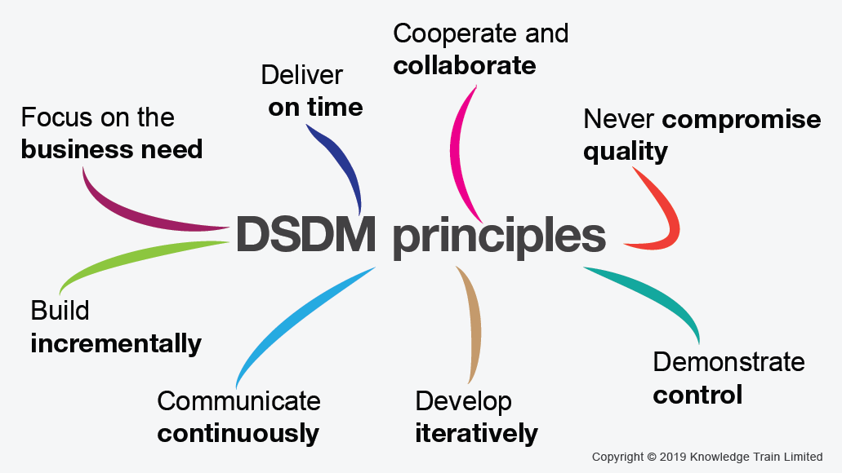

**Life Cycle of DSDM -**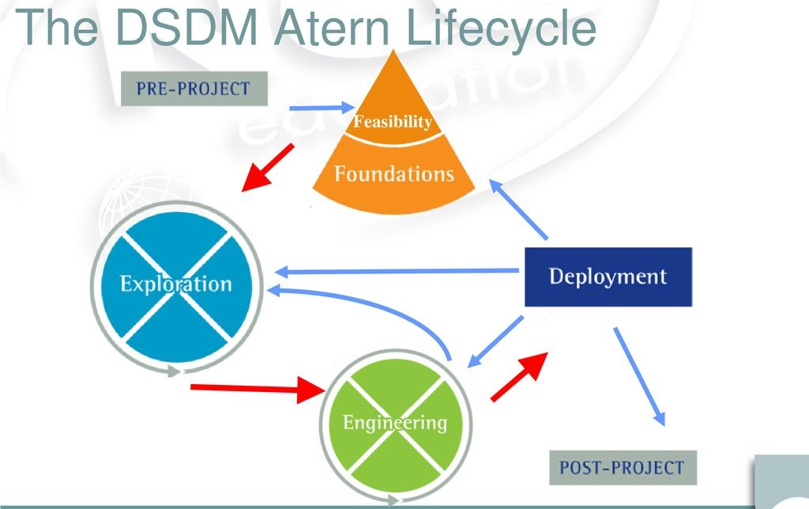

**Disadvantages of DSDM –**

* **Sometime it’s costly.**
* **May not suitable for small organizations.**
* **Not suitable for one time projects.**
* **User and developers both need to be trained.**